**Client-Side App Rubric** <https://github.com/denisecase/pbl-lifeline-links>

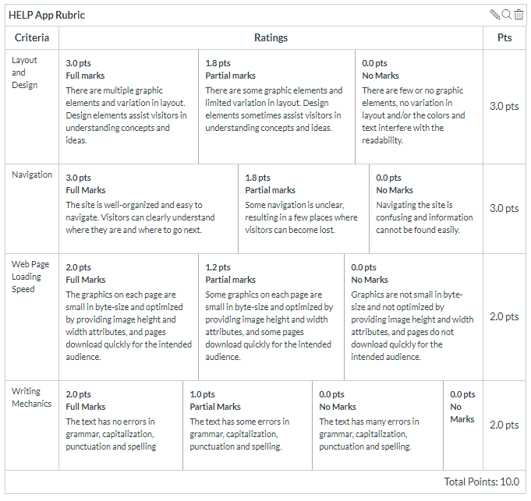

**Team reviewed: 04- Group 8**

**Link to the web site:**

<https://sushmita-rudra.github.io/help-app-08/>

**Layout and Design**

Score: 1.8

Comments:

* Limited graphics
* Unable to see entire family in photo without scrolling
* Footer layout looks good. Still has filler text.
* Quick links does not work
* History page looks good but could use a graphic.
* No footer on Pricing Guideline page.
* Read more on footer brings you to top of homepage. Doesn’t make sense.

**Navigation**

Score: 1.8

Comments:

* Nav is large and takes up a lot of room above the fold.
* Link to google maps is confusing and random. Maybe it should be in the footer or on the contact page.
* Portfolio and contact links are not functional

**Loading Speed:**

Score: 2

Comments:

* Graphic loads quickly but there is only one image.

**Writing Mechanics:**

Score: 1

Comments:

* Still has a ton of filler text.

**General remarks:**

* Needs a footer on every page that is complete.
* We suggest adding more graphics to be more attention grabbing.
* Be sure all links work and go where they are supposed to. We see a lot of links for the sake of just having links. Not good for SEO.
* The nav is huge and takes up a lot of space that could showcase the full image.
* We suggest that you embed the google map instead of having a link because it is unclear and not user-friendly.

**Review performed by:**

**Group 4**

**Date and time performed:**

**12/3 1:20**